**Presence of macroalgal (*Sargassum* spp.) propagules reduces feeding on algal turfs by coral reef fishes**

Andrew S. Hoey, Zoe Loffler, Alexia Graba-Landry, Samuel A. Matthews, Morgan S. Pratchett

**Supplementary material**



**Figure S1**: (a) Position of Lizard Island relative to the Turtle Group Islands, the site of adult *Sargassum* collection; (b) map of Lizard Island showing the location of the exposed reef flat and reef crest sites where the tile pairs were deployed, and location of sheltered site where tiles were placed to allow the establishment of EAM assemblages. Modified from Hoey and Bellwood (2009).

**Height of turf between EAM with propagules and EAM only tiles**

The height of turf assemblages on each tile (both EAM only and EAM with *Sargassum* propagules) was estimated from images taken when the tiles were first deployed on the reef. Measurements of turf height were taken from three random points on each image using the software ImageJ

To examine if the height of turf differed between EAM only and EAM with propagulestiles, a generalised linear model was fitted using the function ‘stan_glm’, with turf height (mm) as the response variable. Substrate (EAM only or EAM with propagulestile) was included as a fixed factor. The model was fitted with a Gaussian error distribution with an identity link transformation and weakly informative priors on intercept (normal(0,10)) and slope coefficients (normal(0,10)) and error standard deviation (cauchy(0,5)). Three chains were used, with 4000 iterations, a warmup of 2000 and a thinning factor of three.

The analysis of turf height between EAM only and EAM with propagulestiles revealed that there was no significant difference in the height of turf between the substrate types, with the turf growing on the EAM with propagulestiles averaging a height of 3.77 [3.18, 4.28] mm and the turf on EAM only tiles averaging a height of 4.17 [3.58, 4.74] mm.

**Table S1**: List of all fish species that were observed taking bites on exposed (i.e., uncaged) tiles. The total number of bites recorded over the five days of video (for both sites and habitats pooled), and the proportion of bites from EAM only vs EAM containing *Sargassum* propagules are given. The highest proportion of bites for each species is shown in bold

|  |  |  |  |
| --- | --- | --- | --- |
| **Fish species** | **Total bites** | **Proportion of bites on EAM with *Sargassum* propagules** | **Proportion of bites on EAM only tiles** |
| *Ecsenius stictus* | 32,838 | 0.43 | **0.57** |
| *Scarus schlegeli* | 1040 | 0.40 | **0.60** |
| *Salarias alboguttatus* | 686 | 0.29 | **0.71** |
| *Ctenochaetus striatus* | 408 | **0.52** | 0.48 |
| *Salarias fasciatus* | 313 | 0.498 | **0.502** |
| *Pomacentrus chrysurus* | 245 | 0.32 | **0.68** |
| *Pomacentrus wardi* | 201 | 0.21 | **0.79** |
| *Stegastes apicalis* | 186 | **0.55** | 0.45 |
| *Acanthurus nigrofuscus* | 185 | 0.35 | **0.65** |
| *Ecsenius yaeyamaensis* | 79 | 0.38 | **0.62** |
| *Stegastes nigricans* | 64 | 0.23 | **0.77** |
| *Ecsenius aequalis* | 34 | 0.41 | **0.59** |
| *Ecsenius bicolor* | 32 | **0.84** | 0.16 |
| *Pomacentrus moluccensis* | 23 | 0.09 | **0.91** |
| *Pomacentrus milleri* | 20 | 0.15 | **0.85** |
| *Dischistodus spp.* | 14 | 0.14 | **0.86** |
| *Zebrasoma scopas* | 14 | 0.07 | **0.93** |
| *Cirripectes sp.* | 10 | 0.40 | **0.60** |
| *Pomacentrus australis* | 6 | 0.17 | **0.83** |
| *Scarus flavipectoralis* | 2 | 0 | **1.00** |
| *Acanthurus dussumieri* | 1 | 0 | **1.00** |

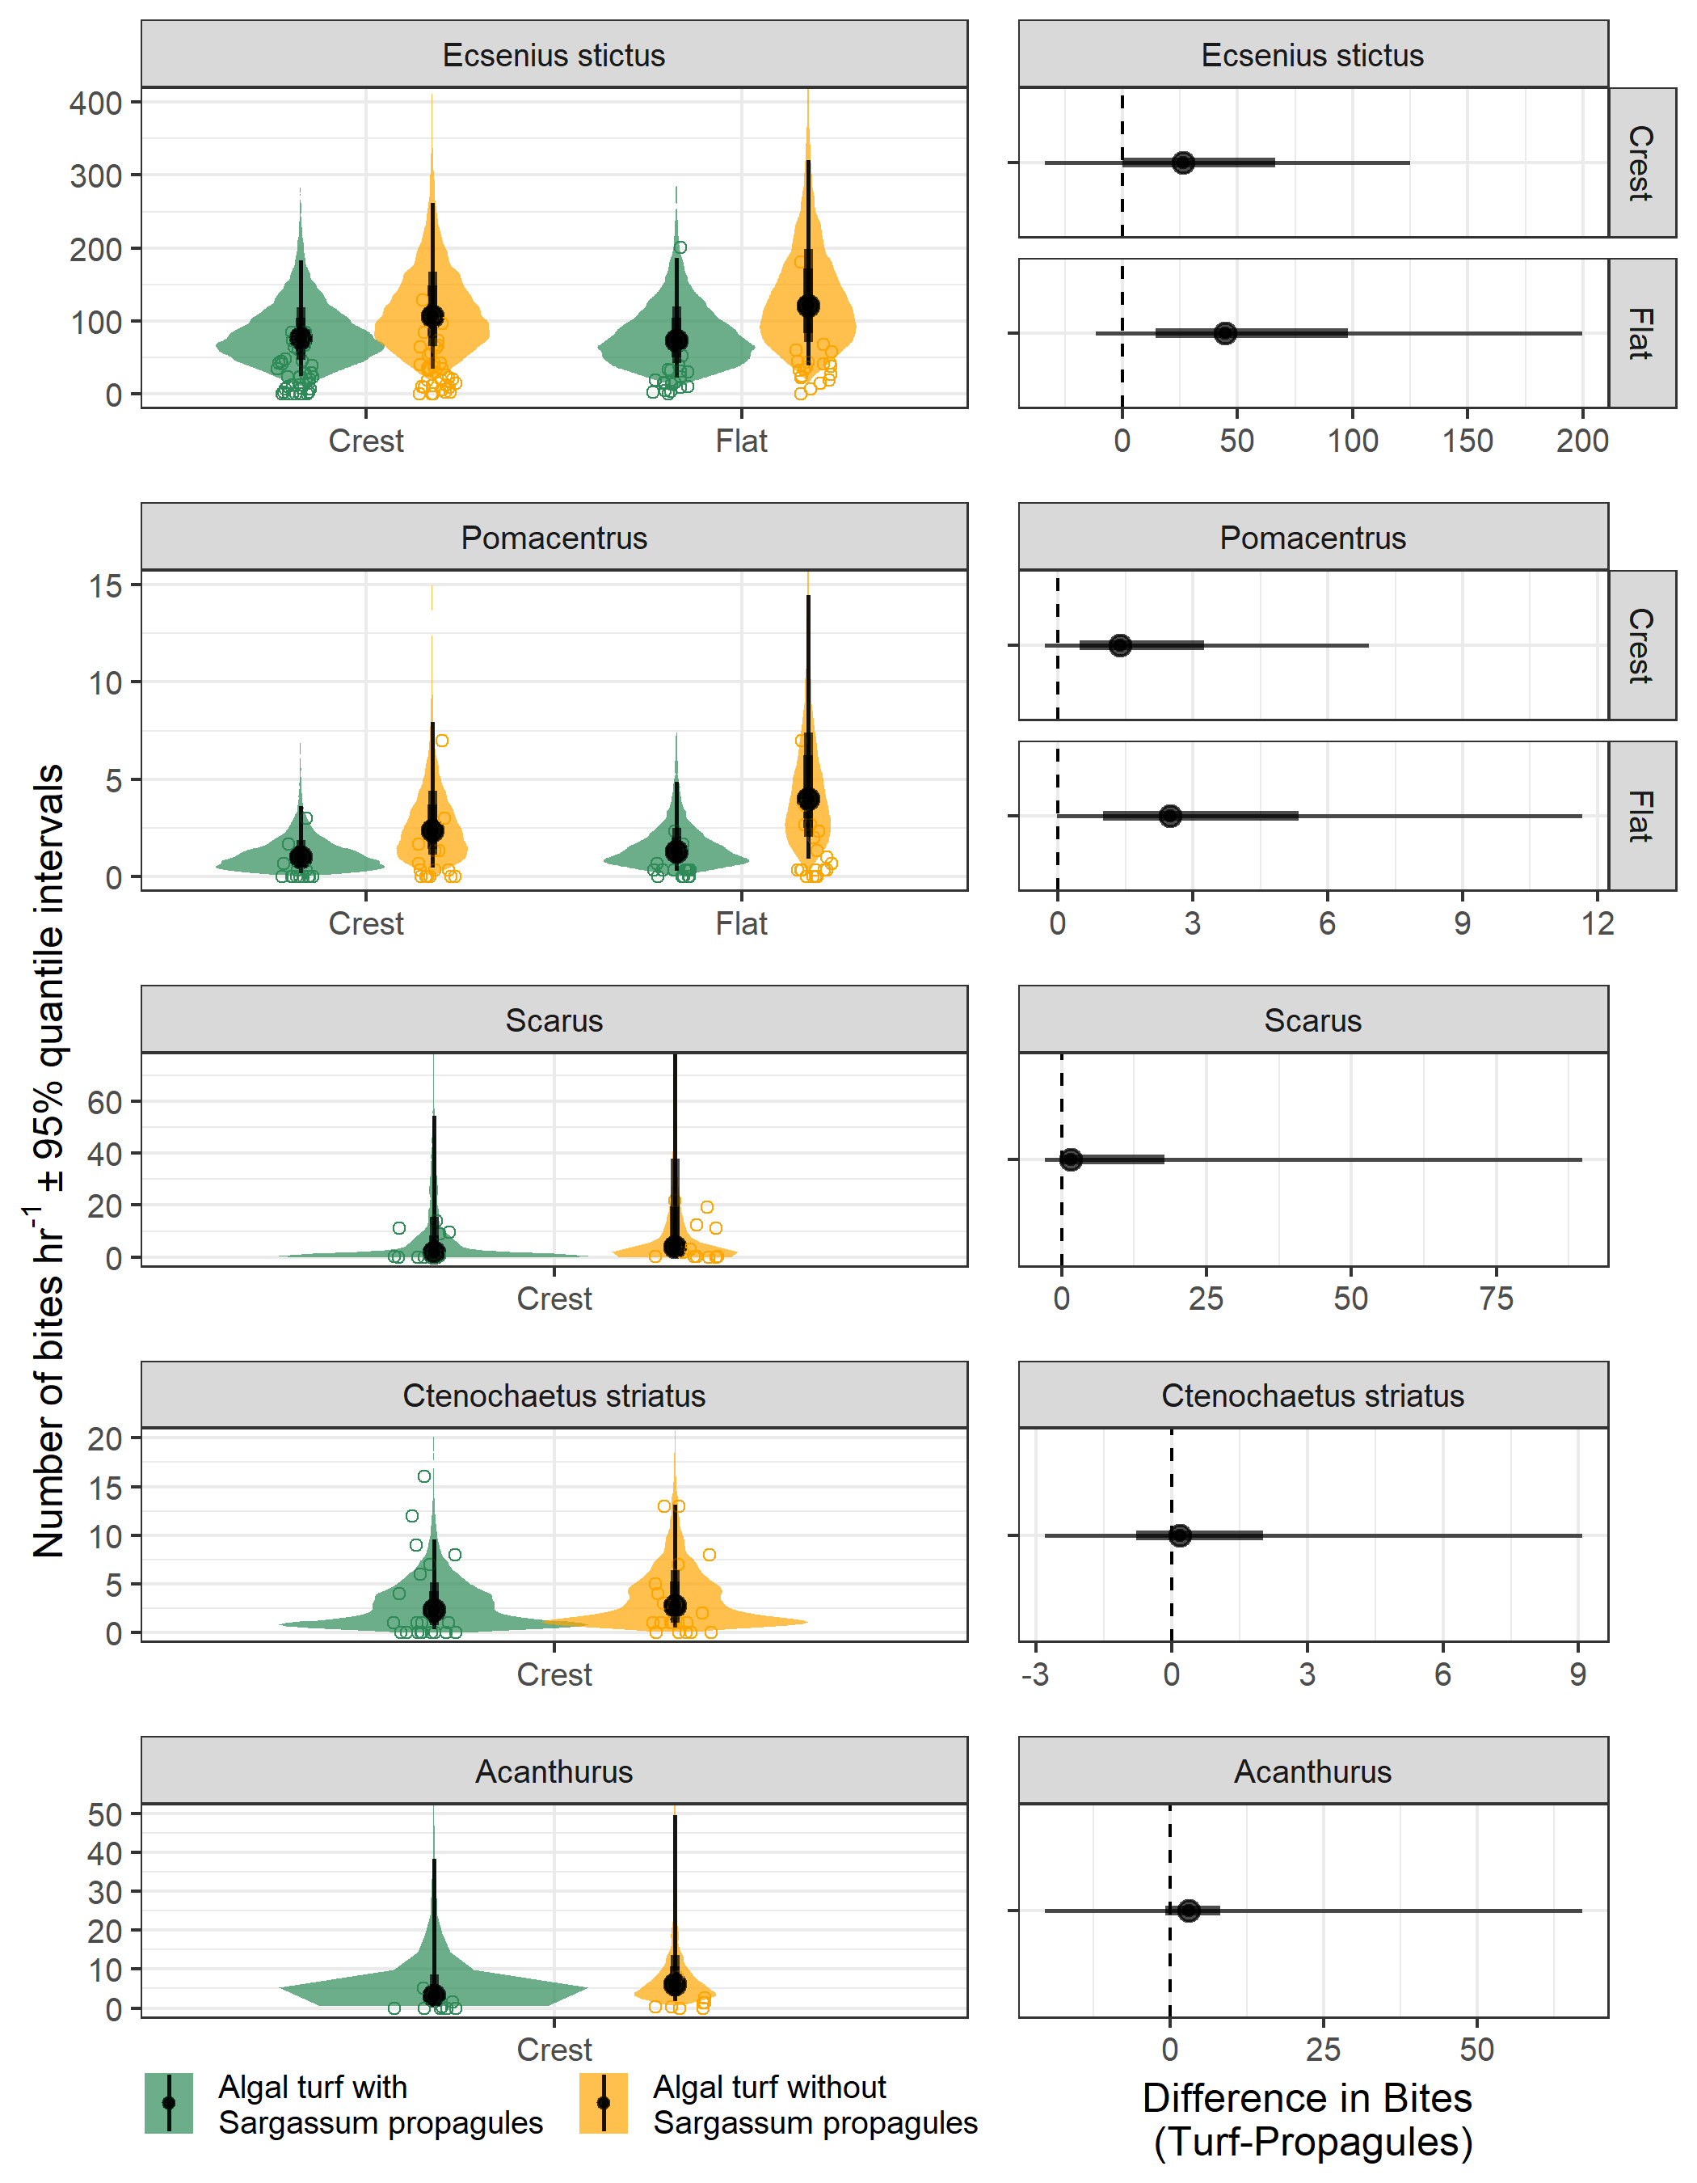

**Figure S2**: Differences in the effect of the presence of *Sargassum* propagules on the bite rates of (a) *Ecsenius stictus*, (b) *Pomacentrus* spp, (c) *Scarus* spp, (d) *Ctenochaetus* *striatus* and (e) *Acanthurus* spp. feeding on algal turf assemblages between sites and habitats (reef crest and reef flat) at Lizard Island. Solid symbols are estimated marginal mean model estimates of Bayesian generalised linear model with gamma distributed errors,  50% and 95% Credible Intervals, and open symbols are the raw data. Shaded areas represent the distribution of the estimated marginal mean. The right hand panel represents the median difference ( 50% and 95% Credible Intervals) between tile with and without *Sargassum* propagules. Note: *Ctenochaetus* *striatus* only took bites on tiles on the reef crest, and bites were pooled across habitats for *Scarus* and *Acanthurus.*